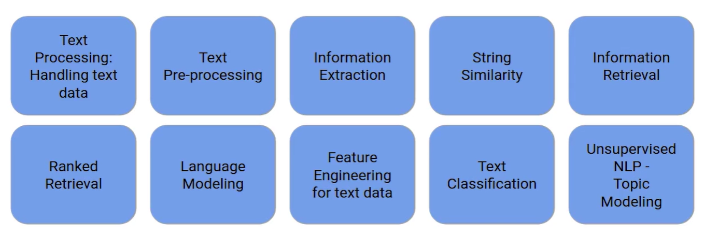

1. Introduction to Natural
2. Language Processing (NLP)
3. Introduction to the course
4. Setting up the system
5. Text Processing: Handling text data
   1. Read data
   2. Regex
6. Text Pre-processing
   1. Stop word removal
   2. Word normalization
7. Information Extraction
   1. What is information extraction?
   2. Part-of-Speech (POS) tagging
   3. POS Tags Implementation
   4. Exercise: Part-of-Speech (POS)
   5. Dependency Parsing
   6. Dependency Parsing Implementation
   7. Exercise: Dependency Parsing
   8. Named Entity Recognition (NER)
   9. NER Implementation
   10. Relation Extraction
   11. Relation Extraction Implementation
   12. Project - [United Nations Debate Analysis](http://localhost:8888/doc/tree/Analytics_Vidhya/Getting%2520Started%2520NLP/6.%2520Information%2520Extraction/6.10%2520United%2520Nations%2520Debate%2520Analysis.ipynb)
   13. Dataset: Social Media Information
   14. Extraction
   15. Assignment: Social Media Information: Extraction
8. String Similarity
   1. Introduction to string similarity
   2. Hamming distance to calculate string similarity
   3. Levenshtein distance to calculate string similarity
   4. Implementing Levenshtein distance
9. Information Retrieval (PDFs only)
   1. Introduction to Information Retrieval
   2. Approaches to Information Retrieval
   3. Inverted Index
   4. Evaluation of Information Retrieval models
10. Ranked Retrieval
    1. Introduction to ranked retrieval
    2. Jaccard Coefficient
    3. Term-Frequency (TF)
    4. Inverse Document Frequency (IDF)
    5. TF-IDF Model - Simply the product of TF and IDF
    6. Vector Space Model
    7. Evaluation of ranked retrieval models
    8. Project: Ranked Retrieval
       1. Understanding the Problem Statement
       2. Loading the Dataset and Retrieving Documents using Jaccard Coefficient
       3. Ranked Retrieval usingTerm Frequency (TF) and Inverse Document Frequency (IDF)
       4. Ranked Retrieval usingTF-lDF and vector space model
11. Language Modeling
    1. Introduction to Language Modeling
    2. Application of Language Modeling
    3. Probabilistic Language Modeling
    4. Evaluation of Language Modeling
    5. Understanding the Problem Statement
    6. Project: Next word Recommender System- Part l
    7. Project: Next word Recommender System-Part II
    8. Dataset for the assignment
    9. Assignment: Language Model using the Reuters Dataset
12. Spelling Correction
    1. Introduction to Spelling Correction
    2. Types of Spelling Errors
    3. Noisy Channel Model for spelling correction
13. Project: Auto Correct
14. Feature Engineering for Text Data
    1. Introduction to Feature Engineering for Text Data
    2. Text Feature Engineering Techniques
    3. Text Feature Engineering Implementation
    4. Exercise: Text Feature Engineering
    5. Text Representation
    6. Text Representation Implementation
    7. Word Embeddings
    8. Word Embeddings Implementation
15. Text classification
    1. Introduction to Text Classification
    2. Hand Coded Rules for Text Classification
    3. Supervised Machine Learning for Text Classification
    4. Understanding Naive Bayes for text classification
    5. Understanding Project SMS spam classification
    6. Implementing SMS spam classifier - Part I
    7. Implementing SMS spam classifier - Part II
    8. Assignment: Twitter Sentiment Analysis
16. Project: Multi class Text
17. Classification
18. Project: Multi label Text Classification
19. Unsupervised NLP - Topic
20. Modeling